**Amazon CloudFront with EC2**

Launch Ec2 instance with Apache webserver.

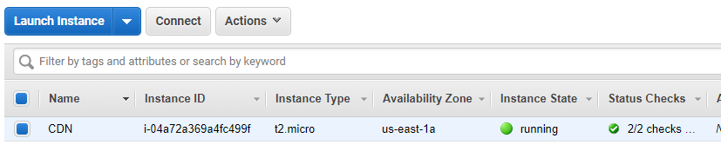

Test the connection in browser and check the traffic where it coming.

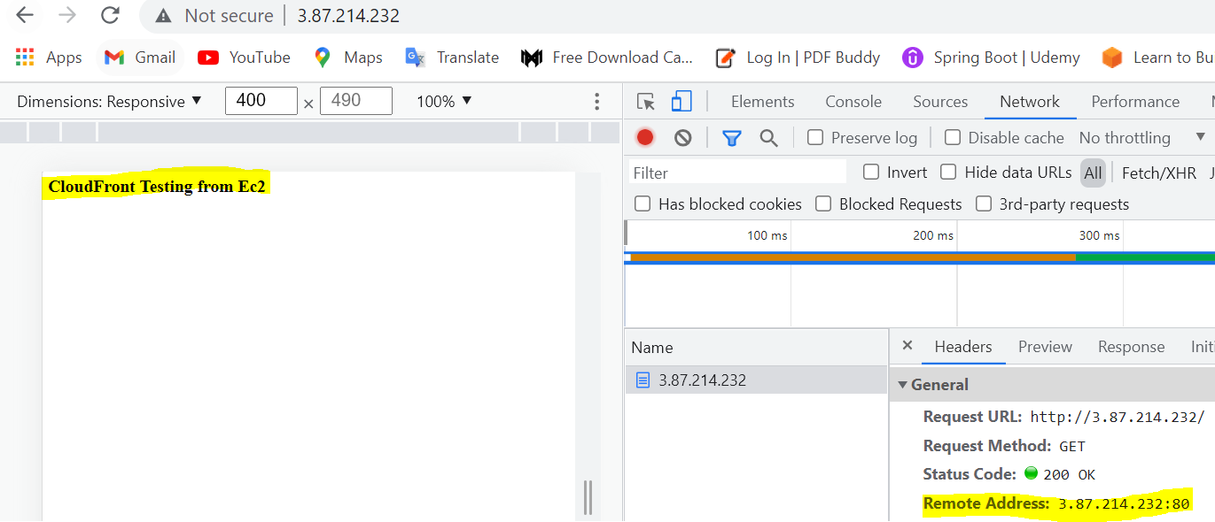

Create domain and register in **Route53**

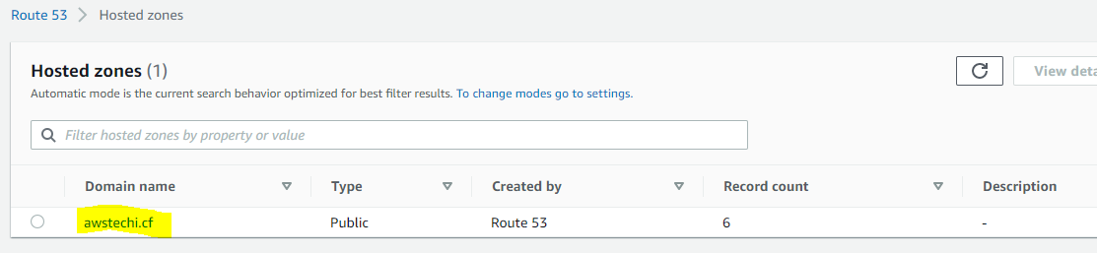

Create SSL in ACM and create CNAME records for it.

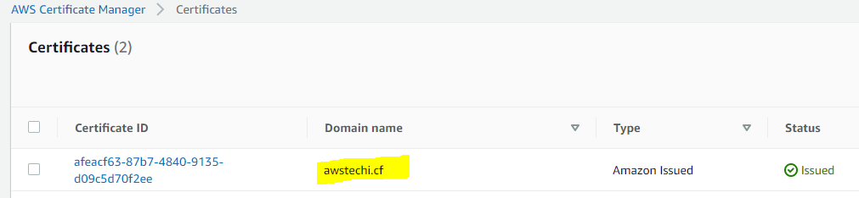

Let’s create Distribution in CloudFront

Enter the EC2 dns name in origin domain

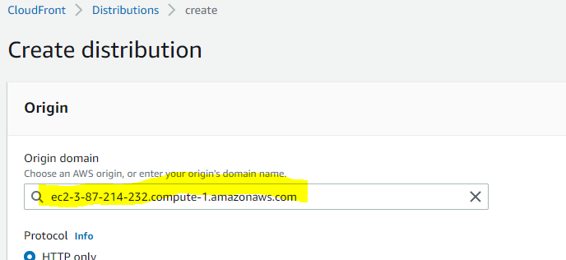

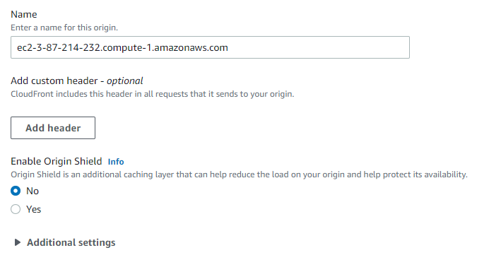

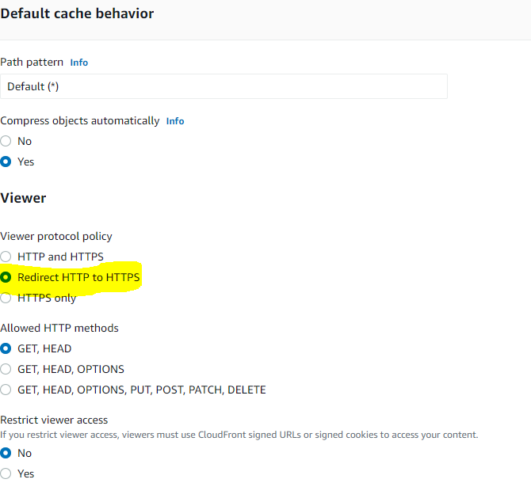

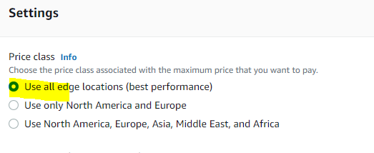

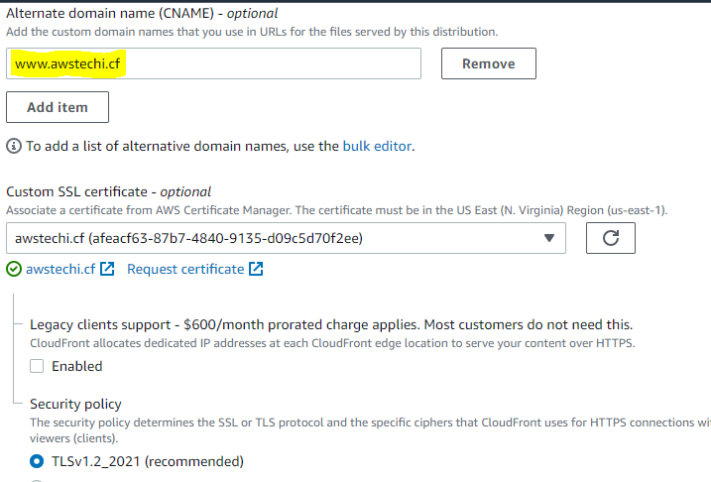

Distribution created successfully

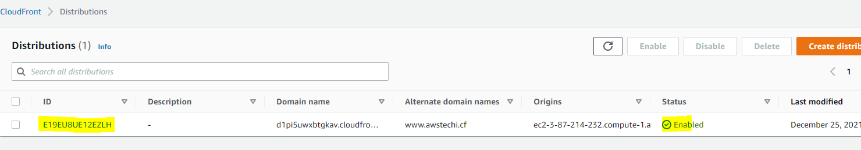

Create A record and route traffic CloudFront Distribution.

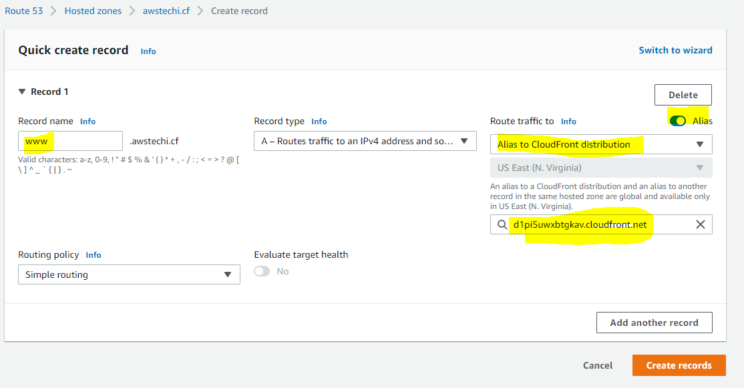

Now the website is launched successfully and securely with Cloudfront

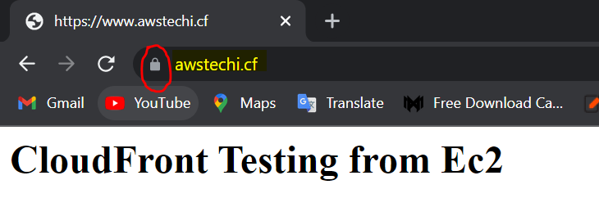

Now the check the real time traffic

